CREATE JAVA APPLICATION

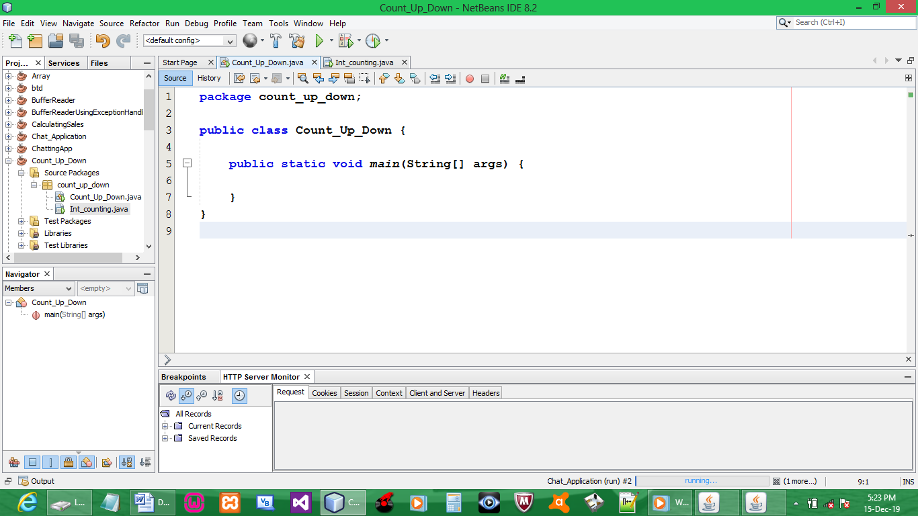

CREATE JAVA FRAME UNDER JAVA APPLICATION PACKAGE

INTERFACE

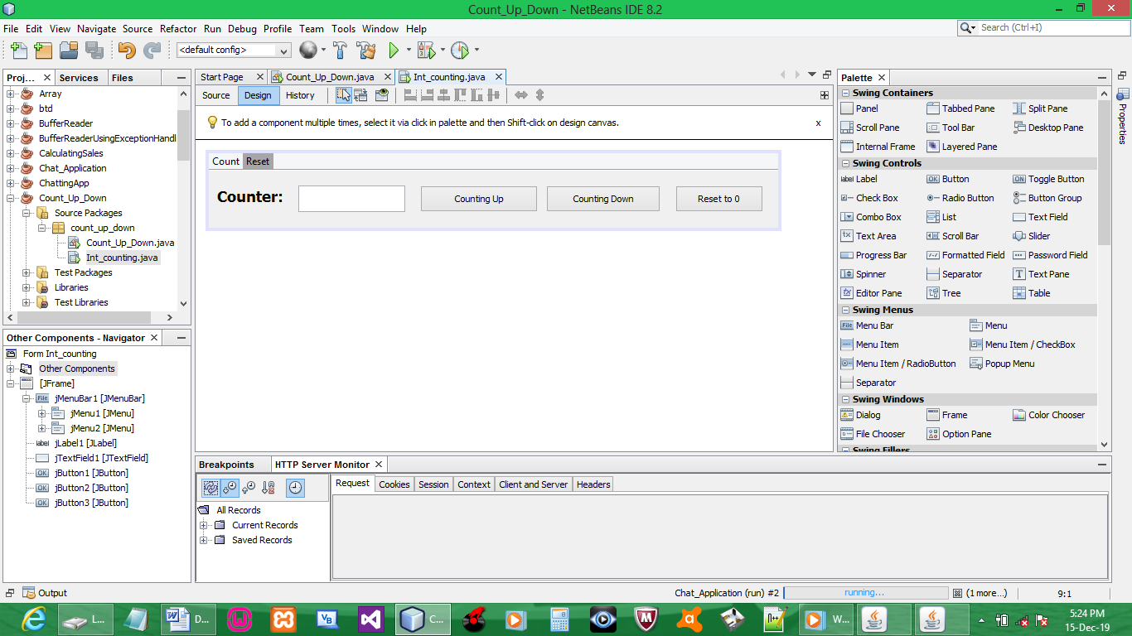

CODE:

import javax.swing.*;
import java.awt.*;
import java.awt.event.*;

ABOVE COUNT UP code
private int x;

COUNT UP BUTTON{
x++;
jTextField1.setText(Integer.toString(x));
}

COUNT DOWN BUTTON{
x--;
jTextField1.setText(Integer.toString(x));
}

RESET BUTTON{
x = 0;
jTextField1.setText(String.valueOf(x));
}

OUTPUT:
Counting up
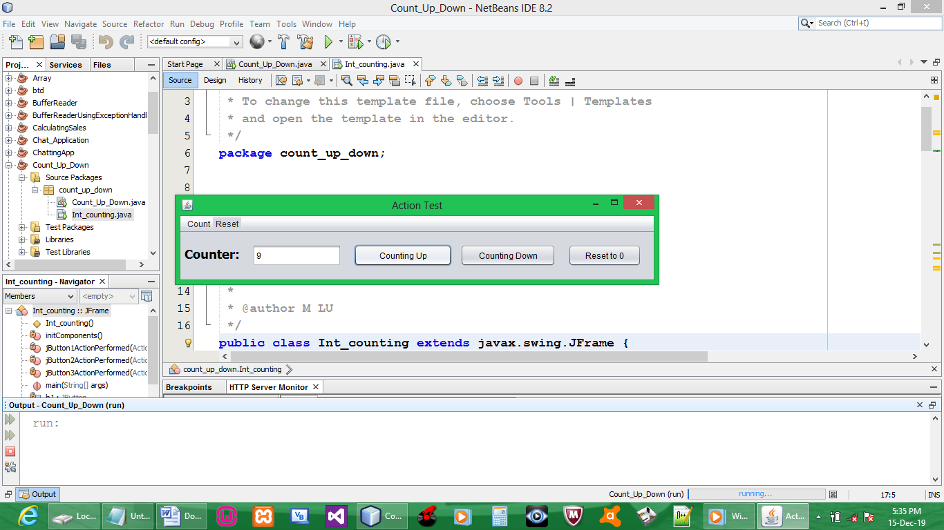

Counting down
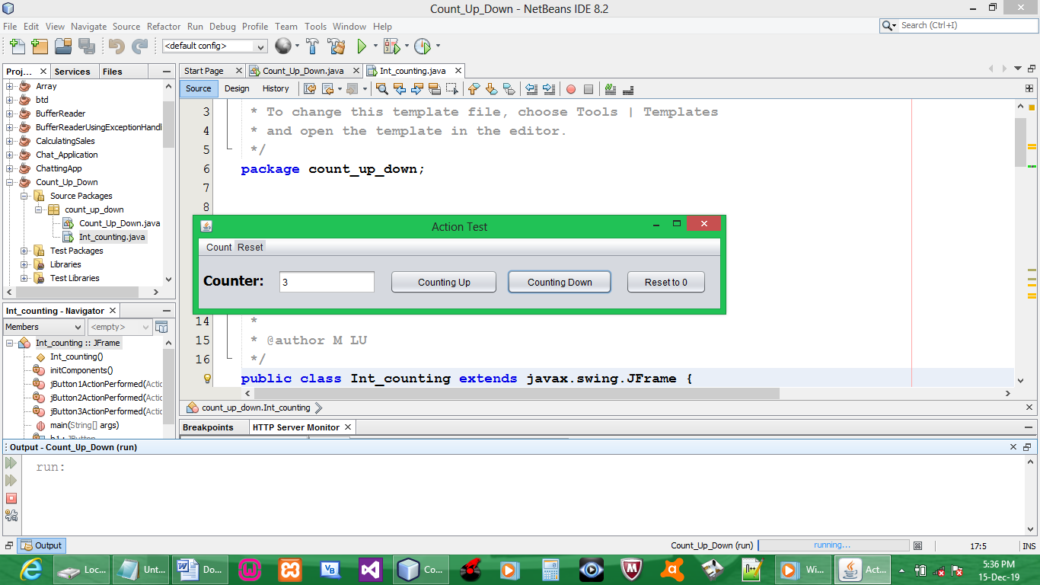

Reset to 0
